Name Density & Income Distribution Application

The application begins as the following screenshot shows:

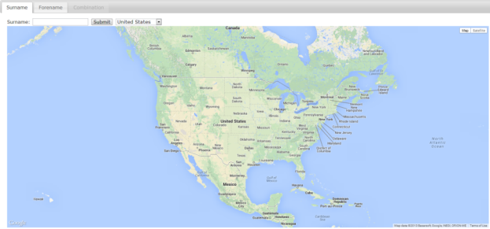

The Surname tab shows information about the user’s surname. It allows for users to input a surname and get results about their surname density in areas around the United States and get their surname income distribution around the United States.

The Forename tab shows information about the user’s forename. It allows for users to input a forename and get results about their forename density in areas around the United States and get their forename income distribution around the United States.

Additionally, each name type has a drop down that allows users to zoom into a specific state within the United States, viewing the name and income distribution for that level. The other map is also zoomed into this level when selected, meaning selecting “California” on the Surname tab will cause the Forename tab to select and zoom into California.

If less than 100 names are loaded for a specific name type, the map does not load and no income distribution information is displayed.

At far zoom levels (country level), the bandwidth for the KDE calculation is 240km. At closer zoom levels (larger states, i.e. California), the bandwidth for the KDE calculation is 100km. At the closest levels (medium and small states), the bandwidth for the KDE calculation is 50km.

The current limit for SQL queries for the name density is 20000.

The Combination tab combines the two name types into a map. This tab is only enabled when both maps for both name types are loaded. The Combination map is formed by doing an and calculation on the color bits of each map.

# Surname Screenshots

The following sections contain screenshots for respective surnames:

## Ibarra

The overall view of surname Ibarra throughout the United States:

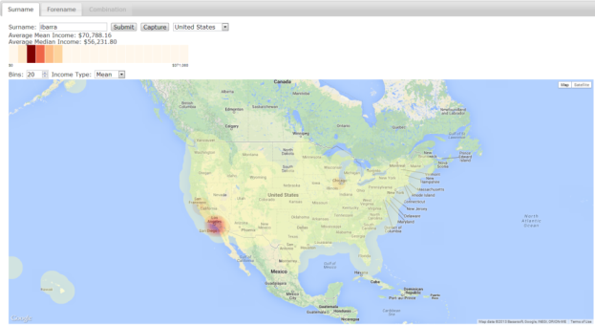

California view of surname Ibarra:

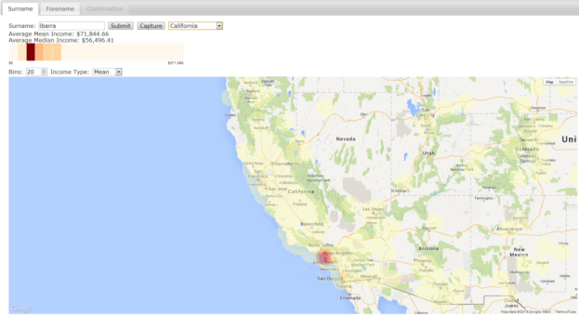

Florida view of surname Ibarra:

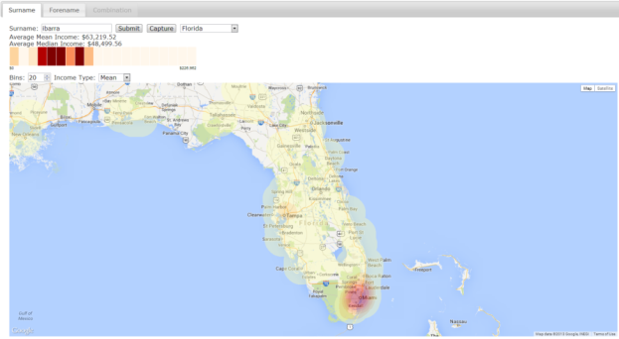

New York view of surname Ibarra:

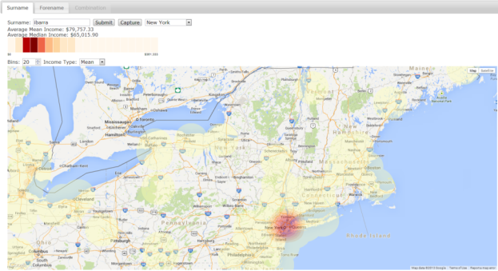

## Maciejewski

The overall view of surname Maciejewski throughout the United States:

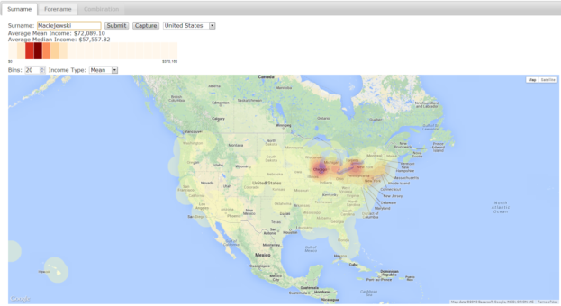

New York view of surname Maciejewski:

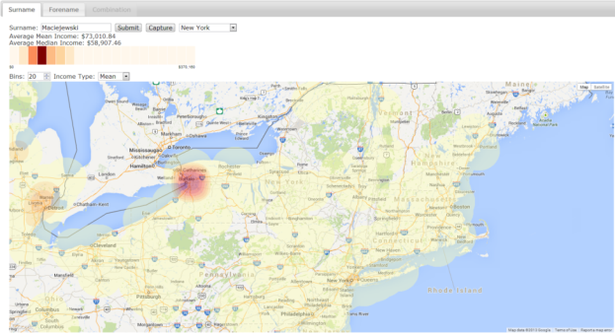

Illinois view of surname Maciejewski:

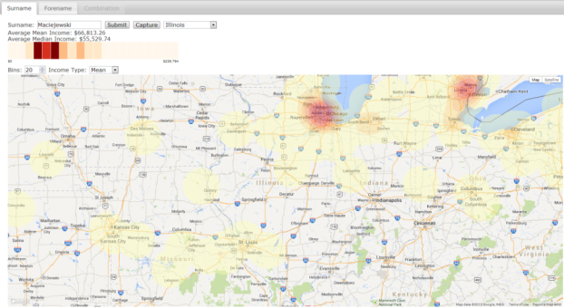

# Forename Screenshots

The following sections contain screenshots for respective forenames:

## Jose

The overall view of forename Jose throughout the United States:

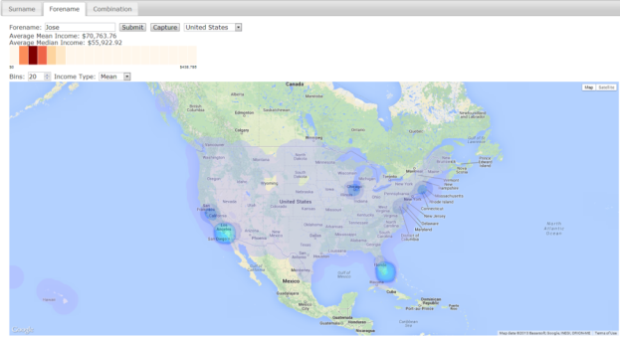

California view of forename Jose:

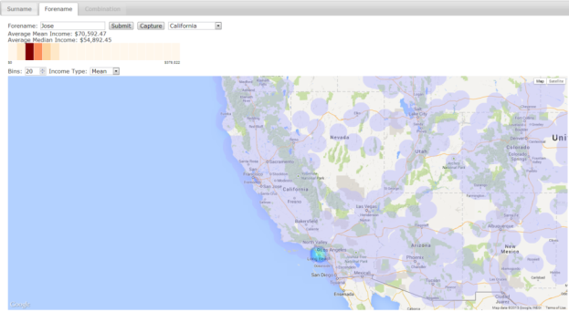

Florida view of forename Jose:

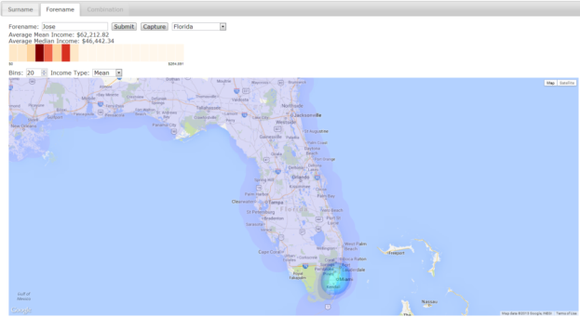

New York view of forename Jose:

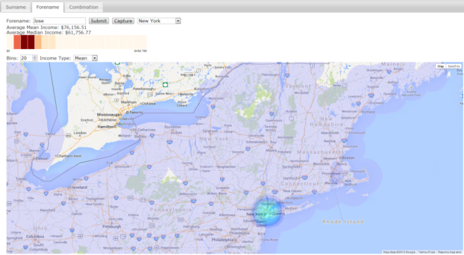

## Ross

The overall view of forename Ross throughout the United States:

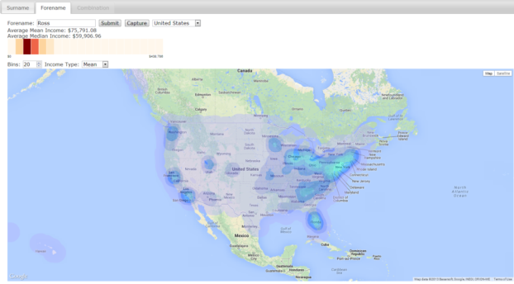

New York view of forename Ross:

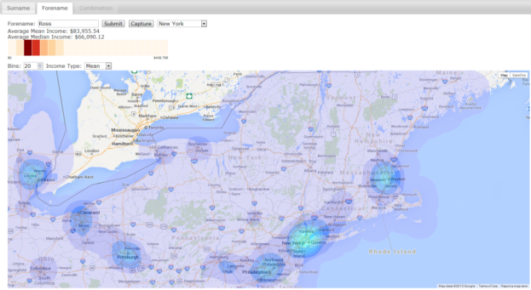

Illinois view of forename Ross:

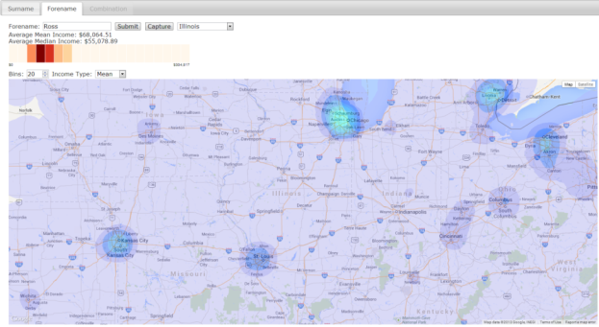

California view of forename Ross:

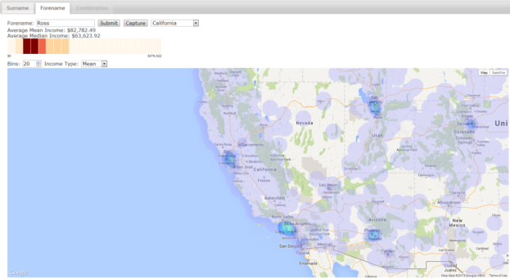

# Combination Screenshots

The following sections contain screenshots for respective combination of forename and surname:

## Jose Ibarra

The overall view of Jose Ibarra throughout the United States:

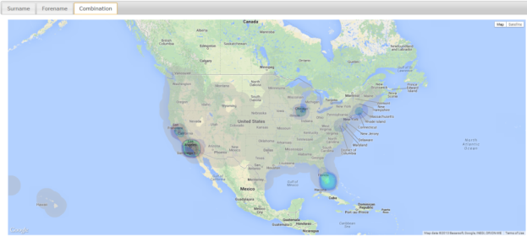

California view of Jose Ibarra:

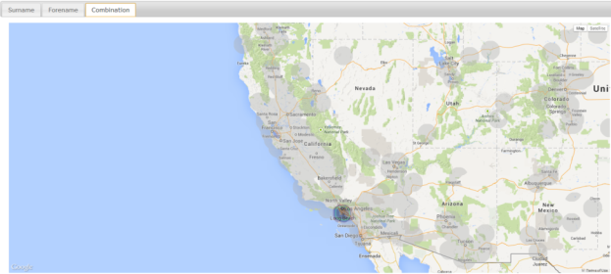

Florida view of Jose Ibarra:

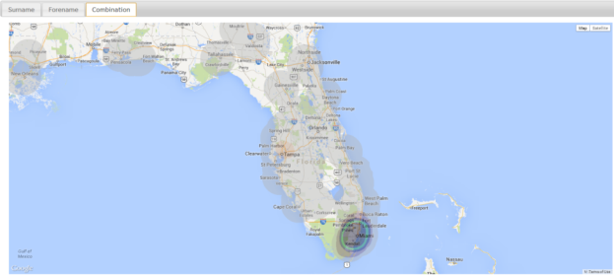

New York view of Jose Ibarra:

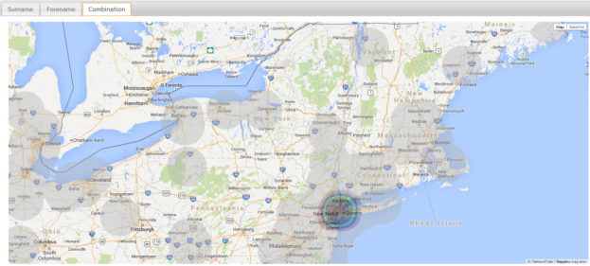

## Ross Maciejewski

The overall view of Ross Maciejewski throughout the United States:

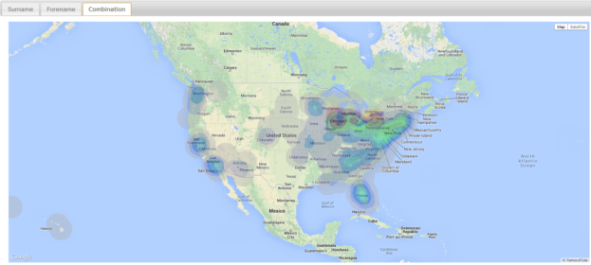

New York view of Ross Maciejewski:

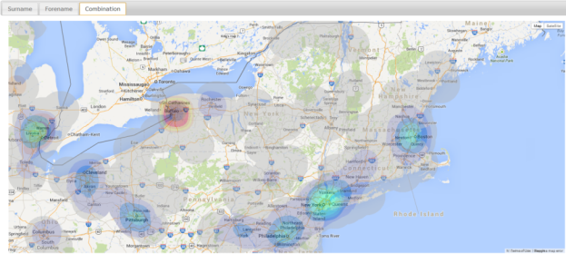

Illinois view of Ross Maciejewski:

